Chapter Portal Guide
Below is a guide to help better navigate the chapter portal and easily find documents and other resources and information to help manage the chapter. After logging into the chapter portal, the links below the red menu bar will appear as highlighted below. Each section contains tools to help manage chapter business.
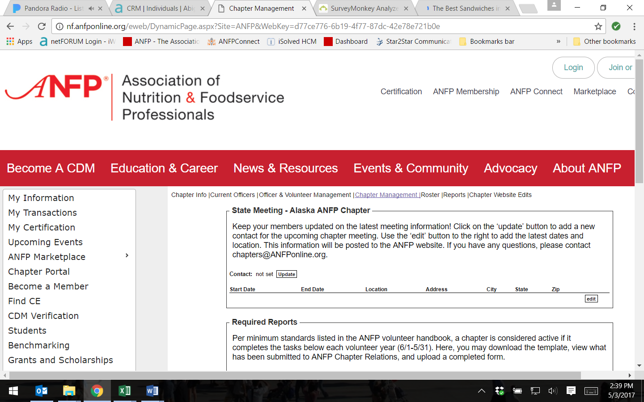

Chapter Info: Under this link, you can find your chapter’s website address, meeting information (if submitted to national) as well as the contact information of your chapter president.
Current Officers: Under this link you will find the listing of your current officers as recognized by national (June 1 – May 31) along with their contact information. You can export this list, by clicking on the ‘Export’ button on the bottom right-hand side.
Officer & Volunteer Management:
Under this link, is where chapter officers and be added/deleted. Chapters officers for the upcoming volunteer year (6/1 – 5/31), can be added as ‘Future Electees’ as early as April 1 each year. If chapter officers are serving for more than one year, they still must be entered into the portal each year. For example, if the chapter president was serving a two-year term, in April of 2017 you would add them as ‘Future Electee (Upcoming term)’. They will automatically be recognized as the current president starting June of 2017. You would enter the name again, the same way the following year. For instructions on how to enter officers into the portal, please see the ‘how to’ available on ANFPConnect, Volunteer Resources, Chapter Management
Chapter Management: Under this link, you can add your chapter meeting information. Additionally, this where you can upload/download award applications templates and other chapter documents that are required of each chapter including the affiliate agreement, chapter awards, 990e-reciept, etc.
Roster: Under this link you can pull your most recent chapter roster. You can filter this list by zip code, certified/non-certified and events. To learn how to pull a roster, please see the how to’ available on ANFPConnect, Volunteer Resources, Volunteer 101.
Reports: Under this link, you can find member reports including new members, inactive members or new students. Simply, click ‘View Report’ and it will download to your computer or device.
Chapter Website Edits: Under this link, you can submit edits for your chapter website. Additionally, if there are documents you would like posted you can attach them on this page as well. Enter the information in the appropriate field and click ‘Submit’.

